MediaQuery
MediaQuery is a Flutter class that tells us about the device.
It provides:
- Screen width
- Screen height
- Orientation
- Text scale
Example:
double width = MediaQuery.of(context).size.width;
double height = MediaQuery.of(context).size.height;
If
width = 360
it's probably a mobile device.
If
width = 800
it's likely a tablet.

Breakpoints
A breakpoint is a width value where the app changes its layout.
Example:
Screen Width | Device
Less than 600 | Mobile
600–900 | Tablet
More than 900 | Desktop

Flutter Example
if (MediaQuery.of(context).size.width < 600) {
return MobileScreen();
} else {
return TabletScreen();
}
"If the screen width is less than 600 pixels, show the mobile layout. Otherwise, show the tablet layout."
Example
Widget build(BuildContext context) {

double width = MediaQuery.of(context).size.width;

if (width < 600) {
return Column(
children: [
Text("Mobile View"),
Icon(Icons.phone_android),
],
);
} else {
return Row(
children: [
Icon(Icons.tablet),
Text("Tablet View"),
],
);
}
}

- Mobile → Widgets arranged vertically using Column.
- Tablet → Widgets arranged horizontally using Row.
SAMPLE EXAMPLE:
students to create:
- One Container
- One Text
- One Button
Then:
- If width < 600 → Arrange using Column.
- Else → Arrange using Row.

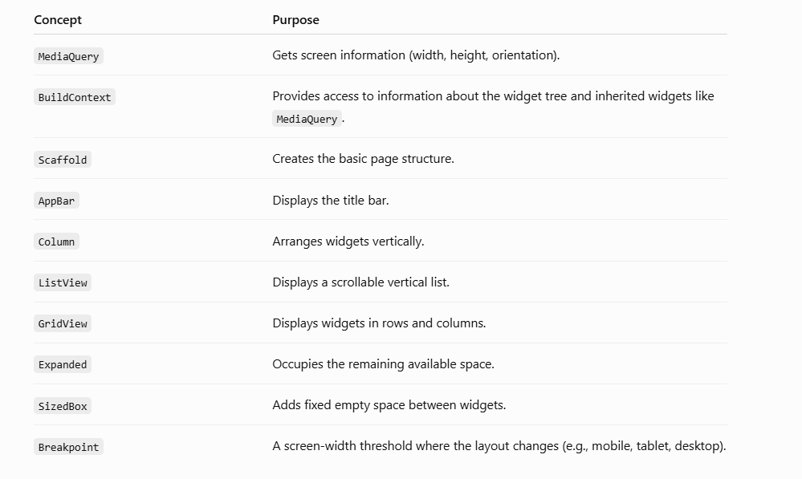

Problem Statement
AIM: Design a Flutter application named Responsive Student Dashboard that changes its user interface according to the device screen size. The application should detect the screen width using MediaQuery and display different layouts for mobile, tablet, and desktop devices.

Requirements
The application must satisfy the following requirements:

1. Application Structure
- Create a Flutter application.
- Display an AppBar with the title "Responsive Student Dashboard".

2. Display Screen Information
Using MediaQuery, display:
- Screen Width
- Screen Height
- Device Orientation (Portrait/Landscape)

3. Device Detection
Implement the following breakpoints:
Screen Width | Device Type
Less than 600 pixels | Mobile
600–899 pixels | Tablet
900 pixels and above | Desktop
Display the detected device type on the screen.

4. Responsive Layout
Design the dashboard using the following layouts:

Mobile View
Arrange all cards vertically using a Column or ListView.

Tablet View
Arrange the cards in 2 columns using GridView.

Desktop View
Arrange the cards in 3 columns using GridView.

5. Dashboard Cards
Create the following cards:
- Student Details
- Attendance
- Marks
Each card should contain:
- An icon
- A title
- A background color

6. Responsive Behaviour
When the screen size changes:
- The layout should automatically update.
- No scrolling issues should occur.
- The UI should remain readable.
TASK:3B
import 'package:flutter/material.dart';
void main() {
runApp(const ResponsiveApp());
}
class ResponsiveApp extends StatelessWidget {
const ResponsiveApp({super.key});
@override
Widget build(BuildContext context) {
return MaterialApp(
debugShowCheckedModeBanner: false,
title: 'MediaQuery Demo',
home: const ResponsiveHome(),
);
}
}
class ResponsiveHome extends StatelessWidget {
const ResponsiveHome({super.key});
@override
Widget build(BuildContext context) {
// Get Screen Width and Height
double screenWidth = MediaQuery.of(context).size.width;
double screenHeight = MediaQuery.of(context).size.height;
// Check Device Type
bool isMobile = screenWidth < 600;
bool isTablet = screenWidth >= 600 && screenWidth < 900;
bool isDesktop = screenWidth >= 900;
return Scaffold(
appBar: AppBar(
title: const Text("MediaQuery & Breakpoints"),
backgroundColor: Colors.blue,
),
body: Padding(
padding: const EdgeInsets.all(20),
child: Column(
crossAxisAlignment: CrossAxisAlignment.start,
children: [
Text(
"Screen Width : ${screenWidth.toStringAsFixed(0)}",
style: const TextStyle(fontSize: 22),
),
Text(
"Screen Height : ${screenHeight.toStringAsFixed(0)}",
style: const TextStyle(fontSize: 22),
),
const SizedBox(height: 20),
if (isMobile)
const Text(
"Device : MOBILE",
style: TextStyle(
fontSize: 28,
color: Colors.red,
fontWeight: FontWeight.bold),
),
if (isTablet)
const Text(
"Device : TABLET",
style: TextStyle(
fontSize: 28,
color: Colors.green,
fontWeight: FontWeight.bold),
),
if (isDesktop)
const Text(
"Device : DESKTOP",
style: TextStyle(
fontSize: 28,
color: Colors.blue,
fontWeight: FontWeight.bold),
),
const SizedBox(height: 30),
Expanded(
child: isMobile
// MOBILE VIEW
? Column(
children: [
buildBox(Colors.red, "Student Details"),
const SizedBox(height: 15),
buildBox(Colors.orange, "Attendance"),
const SizedBox(height: 15),
buildBox(Colors.green, "Marks"),
],
)
// TABLET & DESKTOP VIEW
: Row(
children: [
Expanded(
child: buildBox(
Colors.red, "Student Details"),
),
const SizedBox(width: 15),
Expanded(
child: buildBox(
Colors.orange, "Attendance"),
),
const SizedBox(width: 15),
Expanded(
child: buildBox(
Colors.green, "Marks"),
),
],
),
),
],
),
),
);
}
Widget buildBox(Color color, String title) {
return Container(
height: 150,
decoration: BoxDecoration(
color: color,
borderRadius: BorderRadius.circular(15),
),
child: Center(
child: Text(
title,
style: const TextStyle(
fontSize: 24,
color: Colors.white,
fontWeight: FontWeight.bold),
),
),
);
}
}

